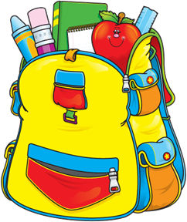

Fill A Need
Sponsor a backpack for a local student:
Donate to CIS of Randolph County during our Fill-A-Need campaign:
Levels:
- $25 provides basic supplies (paper, crayons, glue sticks, pencils, etc.) for one child
- $50 provides a new backpack filled with school supplies for a local
student
- $100 provides two new backpacks with supplies
- Any amount will go to support new school supplies for area students

If donating specific supplies is your preference these are the most desired items:
- Erasers—hand held or pencil top
- #2 pencils
- Glue sticks
- Colored pencils
- Crayons—16 or 24 package
- Pencil pouch (not boxes)
- Folder with pockets
- Highlighters
- headphones
Donations may be mailed or delivered to 1003 Sunset Avenue, Asheboro or may be made online @ www.randolph.communitiesinschools.org

